## Merchant

Demo date: Sep 13th, 2024  
Scoping start date: Sep 13, 2024

MSA Signature Date: Sep 24, 2024  
Onboarding Kick Off Date: Oct 1, 2024

[If Exists] Opt Out Date: N/A  
Go Live Date: Dec 9, 2024

GTM POC: Nick  
Implementation POC: Arjun

ERP: NS

Tax Integration: Avalara

### 

### Key people at Merchant

### Controller: Derrick Rankin

### Head of FP&A: David Leite

### CFO: Tosin Adesegha

* Account Receivable POC: David
* Billing POC: Derrick

### 

| Notes Sections [Ops International Team to Ignore] *(AE/ Implementation to fill)*   * Info on how merchant bills   + Spreadsheets related to usage data pulled on a monthly basis   + Master Excel with all client data   + Number of prescribers broken out in Excel per prescriber   + Tiered unit pricing   + **Receipts of usage data attached to each invoice then sent** * Is there any important merchant relationship information?  1) What is the merchant temperament?   Very calm and open to figuring out solutions together. Technical stakeholders - moved forward because they wanted to work with our team to get rid of their billing headaches  2) Is there a key POC: (i.e.: who is the buyer/decision maker?)  Derrick and David are main stakeholders. Rebecca knows CFO, Tosin, personally.  3) What are the Tabs features that the key POC cares about?  Invoicing, usage upload, receipt attachment, reporting, rev rec |
| --- |

### 

Company summary  
*(AE to fill)*

DoseSpot is a Surescripts certified e-Prescribing platform specifically designed to integrate with electronic health record, electronic dental record, practice management and telehealth software. DoseSpot is certified to e-Prescribe controlled substances and has provided simple, affordable and integratable e-Prescribing solutions to healthcare IT companies since 2009

Goals (North star)  
*(AE/ Implementation to fill)***What is the merchant's goal? What pain are we solving? Why are they buying Tabs?**Usage data upload. Contract management. Attachment of receipts to invoices. Customized Rev Rec reporting

**Is there an opt out clause? If so, what is the merchant looking for so they do not exercise it?**Nope

### Billing model *(AE/ Implementation to fill)*

* Are there unique things about the customer creation process for this merchant?
* Information on how merchant bills
  + Monthly with subscription fee in arrears and tiered usage pricing also in arrears
* How contract is broken up
  + Look at Exhibit A of the MSA for pricing. Specifically, looking for pricing related to:
    - Fixed monthly fee and any prescribers that are included in the cost
    - EPCS Prescribers
    - Non-EPCS Prescribers
    - Prescription Agents
    - Prescriptions
    - Identity Proofing
  + Ignore data related to:
    - EPCS Certification or Re-certification
    - Hardware tokens
* One-off things to know about the merchant
  + There are often typos in the pricing tables. Regardless of what text is shown, the lower priced table is for Non-EPCS and the higher priced table is for EPCS.

### Contract Processing Steps *(Implementation/Success to fill) Sample IDs of accurately processed contracts: (*[*here*](https://garage.tabsplatform.com/prod/contracts/7b6d80c0-ad20-469b-b396-5de7bf9ed2d4/terms/revenue)*)*

1. Steps to process
   1. Assign the contract to a customer
   2. Look in Exhibit A for pricing. Any fixed monthly fee is the subscription fee and is billed **MONTHLY IN ARREARS**.
   3. ~~Monthly fee often includes 10 free prescribers. If so, adjust the contracted tiers of prescribers to be 10 higher than the contract states. For example:~~
      1. ~~Contract says 0-100 prescribers is $10 and 101-1000 prescribers is $8. Contract also says 10 prescribers free.~~
      2. ~~Process this as 11-110 prescribers at $10, and 111-1010 prescribers at $8. Do not include a tier for the free included amount of prescribers.  
         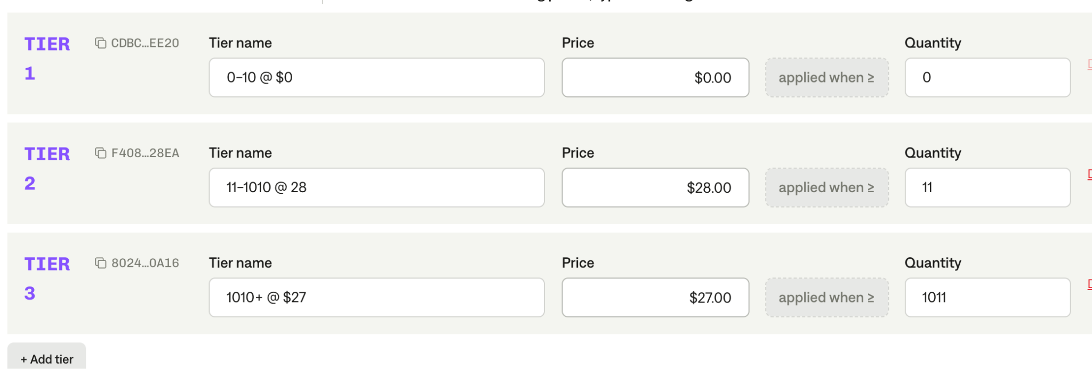~~
   4. There is usually also tiered pricing associated with Non-EPCS prescribers (NON-EPCS), EPCS prescribers (EPCS), and prescriptions (RX). Tiered pricing should include the unit price in the description field.  
      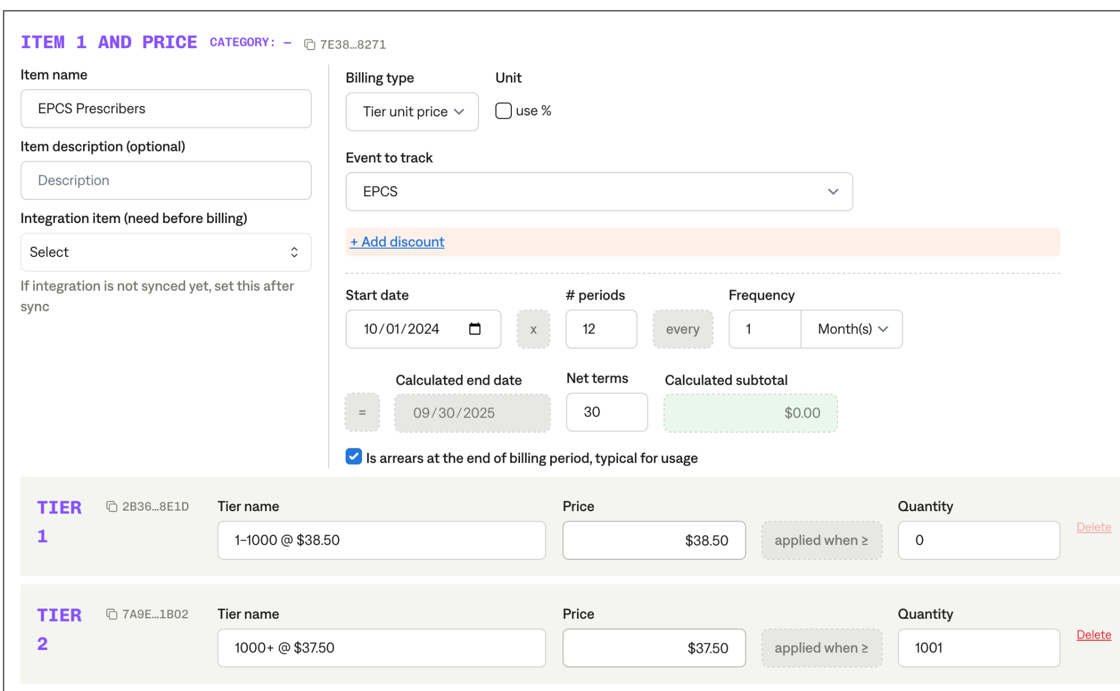  
        
      NEW: Some contracts only contain Non-EPCS Pricing or only contain EPCS Pricing. If only one is in the contract, please still include the other one and use the same pricing. That is, if a contract treats EPCS and Non-EPCS the same, we want billing terms for both so that we can 111be sure they are all billed.
   5. There is usually also unit pricing associated with prescription ag
   6. ents (AGENTS). Unit pricing should include the unit price in the description field. 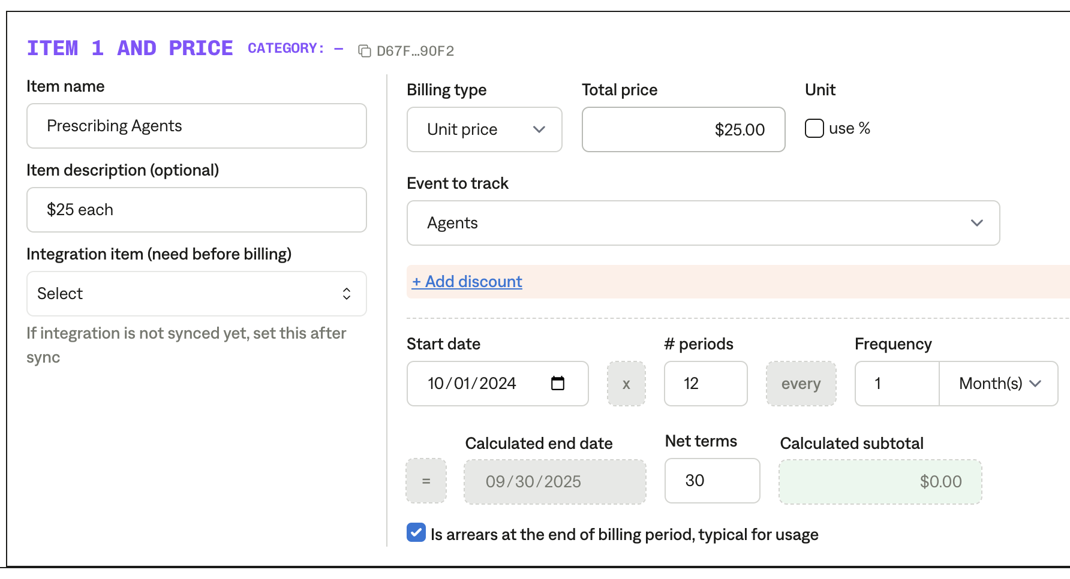
   7. There is usually also unit pricing associated with ID Proofing (IDP). Unit pricing should include the unit price in the description field.   
      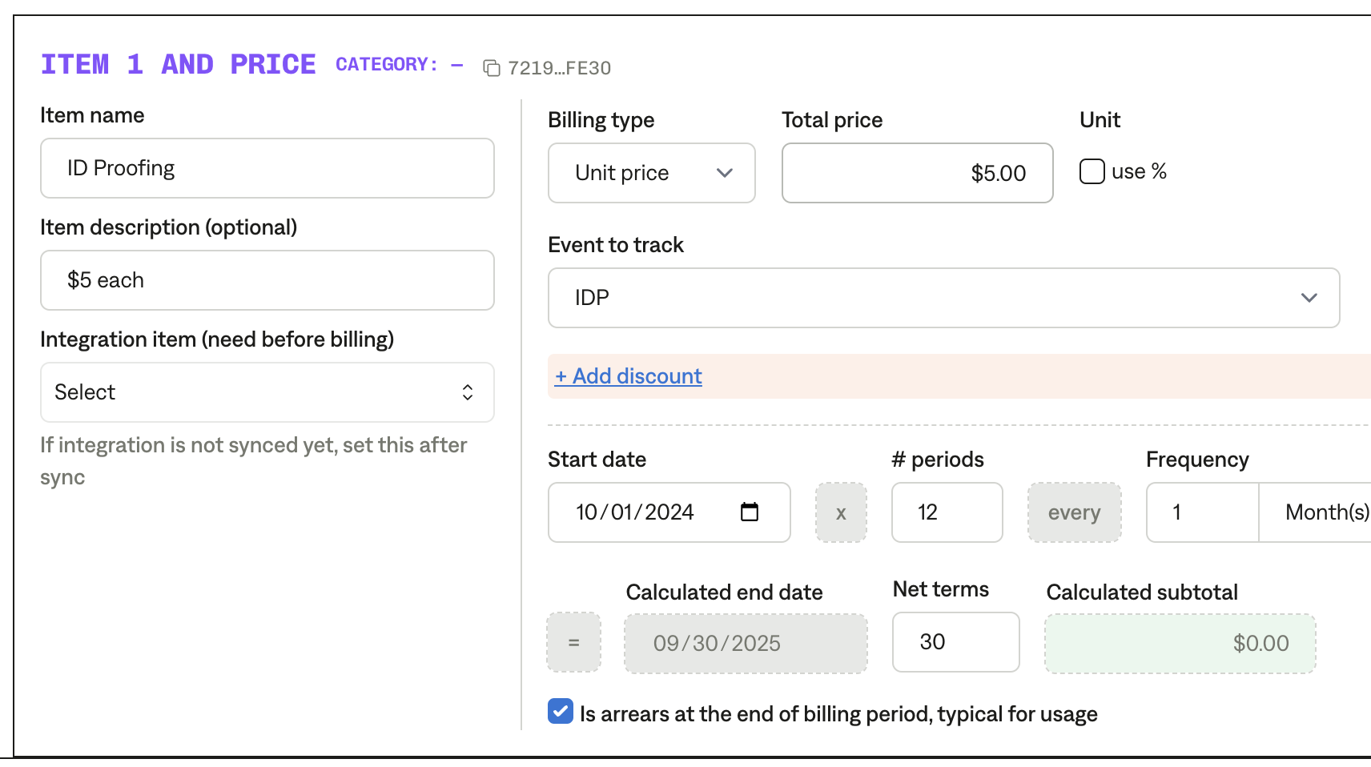
   8. If there is an implementation fee, it is billed on the signature date. This step can be skipped for old contracts (anything uploaded before Nov 1, 2024) because they have already been billed.
   9. NEW: Add an additional revenue schedule and billing term for “Included Prescribers”. This will be UNIT_PRICE with Event to track “FREE” and will be $0 each.
      1. [ ]
2. Anything to ignore in contracts?
   1. Ignore pricing related to Certification, Re-Certification, and Hardware Tokens.
3. Specifics processing things the merchant has requested that may differ by contract (e.g. always back-date invoice date to final day of the month)
   1. None
4. Default Service Term
   1. Always one year starting the first day of the current month (e.g. Oct 1 2024) and with frequency MONTHLY and duration 12 INVOICES.
      1. Signature date is Nov 7, default to Nov 1 first billing date.
5. Default Net Payment Terms
   1. Net 15 in all cases unless an implementation SKU is included and says DUE ON RECEIPT (then use Net 0).
6. Default Billing Frequency
   1. Monthly
7. How do we handle taxes as a line item?
   1. No taxes

### Events Processing (if necessary) *(Implementation/Success to fill)*

* Any important information on events billing
  + Non-EPCS prescribers (NON-EPCS)  
    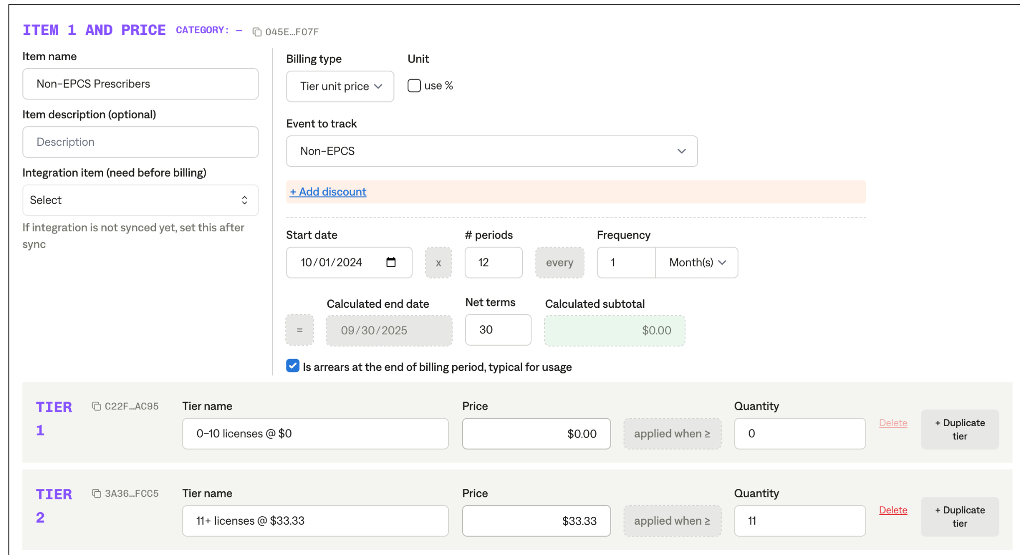
  + EPCS prescribers (EPCS)
  + Prescriptions (RX)
  + Prescription Agents (AGENTS)
  + ID Proofing (IDP)

Integration Items Processing (if necessary)  
*(Implementation/Success to fill)*

NEW: Integration items are below:

| **Item Name** | **Integration Item** | **Event to Track** |
| --- | --- | --- |
| EPCS Prescribers | 216  1U-EPCS | EPCS |
| Non-EPCS Prescribers | 218  1U-NONEPCS | Non-EPCS |
| Agents | 430  1U-AGENT | Agents |
| Prescriptions | 221 1RX | Rx |
| ID Proofing | 410 IDPROOF | IDP |
| Included Prescribers | 433 1U-NONEPCS - First 10 Included | FREE |
| Jumpstart SubscriptionF | 232  JUMP-10U |  |

Post Processing Communications (if necessary)  
*(Implementation/Success to fill)*

* None

### Customer Information *(Implementation/Success to fill)*

* None

### Feature Requests *(AE/Implementation/Success to fill)*

* Auto attachment of usage data to invoices
  + Monthly usage data with # of prescriptions for each invoice
  + This takes Derrick 3 days every month and is one of the main reasons they are signing
  + Professional services work to start, with eventual full automation

### Rewatch Calls *(AE/Implementation/Success to fill)*

* 9/10/24 - AR Heroes Demo
  + <https://tabs.rewatch.com/video/3w2vfbt6yhly27o6-dosespot-tabs-demo-september-10-2024>
* 9/13/24 - Custom Demo
  + <https://tabs.rewatch.com/video/sw57nnmbql1u8zxz-dosespot-tabs-september-13-2024>
* 9/17/24 - Check In call
  + <https://tabs.rewatch.com/video/b02eac0296y1tp57-dosespot-tabs-check-in-september-17-2024>
* 9/19/24 - Netsuite Scoping
  + <https://tabs.rewatch.com/video/0iq2dp0dxbxvpfu3-dosespot-tabs-netsuite-scoping-september-19-2024>
* 9/20/24 - Referral Call with Joe from OpenClinica
  + <https://tabs.rewatch.com/video/td22m9oopx7kqi0q-tabs-reference-joe-openclinica-derrick-david-dosespot-september-20-2024>